

Introduction:

The schema is designed to function as a backend storage database for web application to manage the lumpsum information in many industries. Storing information in a relational database is to identify and implement policies that enhance patient care and foster positive relationships with stakeholders in Healthcare Industry. also all the tasks related to daily functioning of the Healthcare Management system can be performed easily and much more efficiently.

Management system includes registration of patients, storing their details into the system, and also computerized billing. It has the facility to give a unique id for every patient and store the details of every patient.

RDBMS provides many ways to analyze available data, thus helping in making more informed decisions about inventory management, Maintaining customer details, their account and other aspects in Healthcare Management:

* Branch Details
* Treatment Categories
* Patient Details
* Appointment Details

The Relation is best described in the following diagram i.e. ER Diagram-

Entity Relationship Diagram:

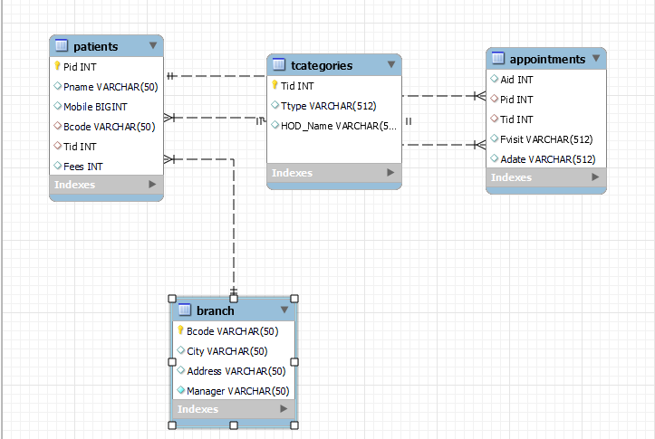

**\* Data Definition Language(DDL):** It allows to create, alter, drop and truncate the structure of tables. As follows:

**Create & Select Database AM Healthcare:**

Create Database AM_Healthcare;

Use AM_Healthcare;

**Create Table for Branch Details:**

Create Table Branch

(

Bcode varchar(50) Primary Key,

City varchar(50),

Address varchar(50),

Manager varchar(50) Not Null

);

**Desc Branch;**

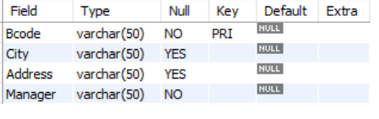

**Create Table for Treatment Categories:**

Create Table Tcategories

(

Tid INT Primary Key,

Ttype VARCHAR(512),

HOD_Name VARCHAR(512)

);

**Desc Tcategories;**

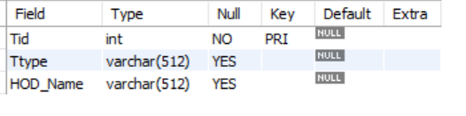

**Create Table for Patients Details:**

CREATE TABLE Patients

(

Pid int Primary Key,

Pname varchar(50),

Mobile bigint,

Bcode varchar(50),

Tid int,

Fees int,

Foreign key (Tid) References Tcategories(Tid),

Foreign key (Bcode) References Branch(Bcode)

);

**Desc Patients;**

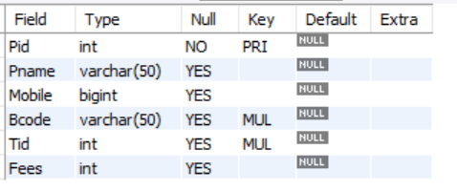

**Create Table for Appointment Details:**

CREATE TABLE Appointments

(

Aid INT,

Pid INT,

Tid INT,

Fvisit VARCHAR(512),

Adate VARCHAR(512),

foreign key (Pid) references patients (Pid),

foreign key (Tid) references Tcategories (Tid)

);

**Desc Appointments:**

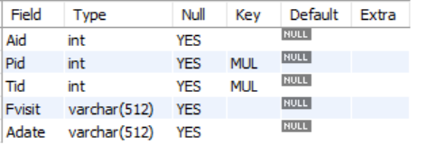

**\* Data Manipulation Language:** It allows Manipulation of data in tables. Like Insert, Update, Delete.

**Insert Data in Branch:**

INSERT INTO Branch VALUES

('M1011', 'Mumbai', '"Mulund station rd, East 05"', 'Punit Shah'),

('T1012', 'Thane', '"Naupada no. 1"', 'Mohan R'),

('P1013', 'Pune', '"Sarasbaug exit gate 2"', 'Waman Pai'),

('S1014', 'Satara', '"Jaoli-satara road, no. 10"', 'Raman R.'),

('K1015', 'Khopoli', '"Khopoli station rd, 1"', 'Jac Dcosta'),

('R1016', 'Raigad', '"Palghar road E01"', 'Tina Dabi'),

('D1017', 'Dombivli', '"Diva bypass exit no. 12"', 'M.Suman'),

('N1018', 'Nagar', '"Near Ahemadnagar Station no. 8"', 'R. Madhavan'),

('B1019', 'Belapur', '"sector 10, Near Station, 14"', 'Varun Sharma');

**Insert Data in Tcategories:**

INSERT INTO Tcategories VALUES

(1001, 'Gaenocology', 'Suresh Aade'),

(1002, 'Orthopaedic', 'Sunita magar'),

(1003, 'Dental', 'Nilesh Shinde'),

(1004, 'Hairloss', 'Suraj Chavan'),

(1005, 'Cardiologist', 'Prakash Shende'),

(1006, 'Neurologist', 'Ritu Khemani'),

(1007, 'Physician', 'Monica M'),

(1008, 'Dietician', 'Siddh Jha'),

(1009, 'Hepatologist', 'Chatur R');

**Insert Data in Patients:**

INSERT INTO Patients VALUES

(101, 'Sonal Sharma', 9876543210, 'M1011', 1005, 1000),

(102, 'Monica C', 9876543211, 'S1014', 1007, 300),

(103, 'Mohan Chandran', 9876543212, 'K1015', 1005, 1000),

(104, 'Radhika P', 9876543213, 'T1012', 1001, 500),

(105, 'C krishnan', 9876543214, 'R1016', 1002, 500),

(106, 'Verma rani', 9876543215, 'S1014', 1001, 500),

(107, 'T Gangopadhayay', 9876543216, 'R1016', 1006, 1200),

(108, 'Mozelle Isac', 9876543217, 'P1013', 1009, 1000),

(109, 'Sharat Kumar Arora', 9876543218, 'K1015', 1003, 500),

(110, 'Afifa Rahman', 9876543219, 'P1013', 1002, 400),

(111, 'Abdul Matin', 9876543220, 'S1014', 1004, 800),

(112, 'Yogesh Sharma', 9876543221, 'T1012', 1005, 1000),

(113, 'Mohit Bhatnagar', 7896541230, 'M1011', 1008, 600),

(114, 'Chanchal Agrawal', 7896541231, 'P1013', 1006, 1000),

(115, 'U Sharma', 7896541232, 'D1017', 1006, 1000),

(116, 'Avantika Srivastava', 7896541233, 'R1016', 1001, 500),

(117, 'Manisha Mane', 7896541234, 'K1015', 1001, 500),

(118, 'A Anandkar', 7896541235, 'B1019', 1007, 300),

(119, 'M R Dhot', 7896541236, 'N1018', 1006, 1000),

(120, 'Rajendra Marwade', 7896541237, 'D1017', 1003, 500),

(121, 'Swati Sanjay Surve', 7896541238, 'K1015', 1007, 300),

(122, 'PRAGYA PANDEY', 7896541239, 'T1012', 1005, 1000),

(123, 'Kanchalal R Patel', 8521479630, 'M1011', 1002, 500),

(124, 'Verma rani', 9876543215, 'S1014', 1004, 800),

(125, 'Abdul Matin', 9876543220, 'S1014', 1002, 400),

(126, 'Afifa Rahman', 9876543219, 'P1013', 1007, 300),

(127, 'Urmila A Thakar', 8521479631, 'R1016', 1001, 500),

(128, 'V Karnick', 8521479632, 'D1017', 1002, 500),

(129, 'Gita B Desai', 8521479633, 'N1018', 1004, 800),

(130, 'Pravin A Jani', 8521479634, 'K1015', 1008, 600),

(131, 'Vijayakumar J K', 8521479635, 'T1012', 1009, 1200),

(132, 'Upadhyay Purnima', 8521479636, 'M1011', 1001, 700),

(133, 'Sharmishtha Patel', 8521479637, 'R1016', 1007, 200),

(134, 'Laila Farzana', 8521479638, 'S1014', 1004, 1000),

(135, 'Aswani Kumar', 8521479639, 'P1013', 1008, 600),

(136, 'Ashaben Dave', 8521479640, 'B1019', 1005, 1000),

(137, 'Manisha Shah', 9654123078, 'D1017', 1009, 1000),

(138, 'Omveer Singh', 9654123077, 'R1016', 1003, 500),

(139, 'Om Prakash Singh', 9654123076, 'B1019', 1005, 1000),

(140, 'Oasis Basu', 9654123075, 'N1018', 1002, 500),

(141, 'Geeta Devi', 9654123074, 'S1014', 1003, 500),

(142, 'Gayathri Sen', 9654123073, 'T1012', 1001, 700),

(143, 'Gurmeet Kaur', 9654123072, 'K1015', 1005, 1000),

(144, 'Gayathri Devi', 9654123071, 'R1016', 1001, 700),

(145, 'Deepa Devi', 9654123070, 'B1019', 1009, 1200),

(146, 'Devaoas Bodugala', 9654123069, 'N1018', 1002, 500),

(147, 'Digvijai Singh', 9654123068, 'M1011', 1003, 500),

(148, 'Wipin Lilhare', 9654123067, 'S1014', 1006, 800),

(149, 'Wajih A Alvi', 9654123066, 'K1015', 1006, 1200),

(150, 'Wazir Singh Mour', 9654123065, 'P1013', 1006, 1200),

(151, 'Tejaswini R Joshi', 9654123064, 'T1012', 1008, 500),

(152, 'Manisha Shah', 9654123078, 'D1017', 1004, 700),

(153, 'Radhika P', 9876543213, 'T1012', 1007, 200),

(154, 'Manisha Shah', 9654123078, 'D1017', 1006, 800),

(155, 'Radhika P', 9876543213, 'T1012', 1008, 500),

(156, 'Mozelle Isac', 9876543217, 'P1013', 1002, 400),

(157, 'Mozelle Isac', 9876543217, 'P1013', 1007, 200),

(158, 'Sharmishtha Patel', 8521479637, 'R1016', 1002, 400),

(159, 'Wipin Lilhare', 9654123067, 'S1014', 1007, 200),

(160, 'Tejaswini R Joshi', 9654123064, 'T1012', 1001, 500);

**Insert Data in Appointments:**

INSERT INTO Appointments VALUES

(5001, 110, 1002, now(), Date_add(Now(),Interval 18 day)),

(5002, 111, 1004, now(), Date_add(Now(),Interval 21 day)),

(5003, 133, 1007, now(), Date_add(Now(),Interval 45 day)),

(5004, 126, 1007, now(), Date_add(Now(),Interval 30 day)),

(5005, 137, 1009, now(), Date_add(Now(),Interval 30 day)),

(5006, 124, 1004, now(), Date_add(Now(),Interval 25 day)),

(5007, 135, 1008, now(), Date_add(Now(),Interval 90 day)),

(5008, 132, 1001, now(), Date_add(Now(),Interval 30 day)),

(5009, 139, 1005, now(), Date_add(Now(),Interval 30 day)),

(5010, 140, 1002, now(), Date_add(Now(),Interval 15 day)),

(5011, 129, 1004, now(), Date_add(Now(),Interval 10 day)),

(5012, 143, 1005, now(), Date_add(Now(),Interval 20 day)),

(5013, 147, 1003, now(), Date_add(Now(),Interval 90 day)),

(5014, 149, 1006, now(), Date_add(Now(),Interval 56 day)),

(5015, 148, 1006, now(), Date_add(Now(),Interval 50 day)),

(5016, 151, 1008, now(), Date_add(Now(),Interval 30 day)),

(5017, 152, 1004, now(), Date_add(Now(),Interval 25 day)),

(5018, 156, 1002, now(), Date_add(Now(),Interval 15 day)),

(5019, 158, 1002, now(), Date_add(Now(),Interval 21 day)),

(5020, 160, 1001, now(), Date_add(Now(),Interval 16 day));

**\* Data Query Language:** It helps in retrieving the data and information from the database. Using Select, Show, Help.

* **Data Control Language:** Allows or denies permissions to access the tables.

* **Transaction Control Language:** It looks upon managing the changes made in DML statement.

1.How Many tables are available in AM Healthcare management system?

Ans:

Show Tables;

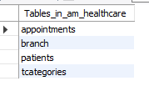

2. Change the treatment id 1001 to patient having id 133 in appointments table?

Ans:

update Appointments

set Tid=1001

where pid=133;

3 .Name the patients who have appointments for Hairloss and Orthopaedic?

Ans:

Select Pname from patients join Tcategories on patients.Tid=Tcategories.Tid where Ttype='Hairloss' or Ttype='Orthopaedic';

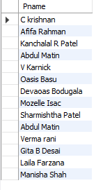

4. What is the collection of every branch till date collection amount low to high?

Ans:

Select City,sum(Fees) as Collection from Branch join patients on Branch.Bcode=patients.Bcode group by city order by sum(fees);

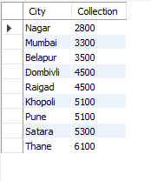

5. How many patients were dignosed in every location?

Ans:

select City, count(Pname) as No_of_patients from patients join Branch

on patients. Bcode=branch.Bcode

group by City;

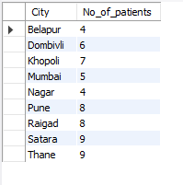

6. How many patients do not advised further revisits?

Ans:

select patients.pname from patients left join

Appointments on patients.pid=Appointments.pid

where Patients.pid not in (select pid from appointments);

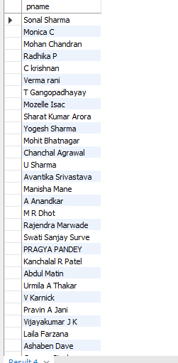

7. Name and fees for gaeno treatment for Raigad branch?

Ans:

Select pname, fees from patients p join Tcategories t

on p.Tid=t.Tid join branch b on b.Bcode=p.Bcode

where Ttype='Gaenocology' and b.bcode='R1016';

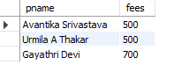

8. Id’s and names of patients have appointments on 5th dec to 25th dec for 1001,1007 &1009 Treatment code for Nagar branch.

Ans:

Select p.pid, p.pname from Patients p left join Appointments a on p.pid=a.pid

join Branch b on p.bcode=b.bcode

where Adate between '2023-12-05 00:28:23' and '2023-12-25 00:28:23'

and city=(select city from branch where bcode='N1018');

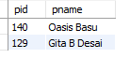

9. Need patients details for thane, pune, raigad and nagar branch?

Ans-

Select * from Patients p left join Branch b on p.bcode=b.bcode where city in (select city from branch where city='Mumbai' or city= 'Raigad' or city= 'Pune' or city= 'Nagar');

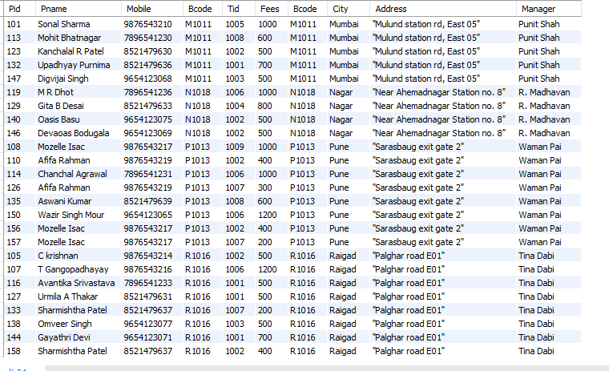

10. Want to know appointment details of thane branch?

Ans:

Select a.pid, b.bcode, pname, adate from Appointments a join Patients p on a.pid=p.pid join Branch b on p.bcode=b.bcode where city='Belapur’;

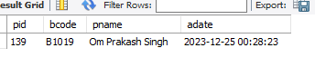

11. How many patients opted for more than 1 treatment?

Ans:

Select pname, count(pname) as Patients from patients group by pname having count(pname) > 1 ;

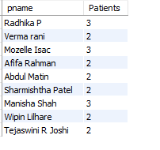

12. Name the patients have appointments came for Neurologist and DIetician in ascending order by name?

Ans:

select pname, Ttype, adate from patients p join Tcategories t on p.tid=t.tid

join appointments a on p.pid=a.pid

where Ttype in (Select Ttype from Tcategories where tid=1006 or tid=1008)

order by pname;

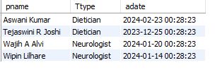

13. name and total fees paid by every patient where fees more than 1000?

Ans:

Select pname, Sum(fees) from Patients

Group by pname

Having sum(fees)>1000;

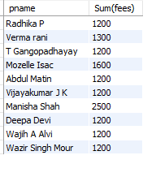

14. Treatment name and mobile no. of patients whose mobile no starts with 9.

Ans:

Select Ttype, Mobile from Patients p join Tcategories t on p.Tid=t.Tid where Mobile like '9%';

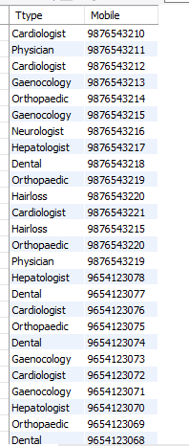

15. What is total collection of AM Healthcare?

Ans:

Select Sum(fees) as Total from patients;

